# *Lab 12 – Sequence & Class Diagrams Review*

Date assigned: Wednesday, March 29, 2017

Date due: **Wednesday, March 29, 2017, 16:50**

**Learning Objectives**

Upon successful completion of this lab exercise, the student will be able to:

* Practice with Sequence Diagrams and Class Diagrams
* Practice with LucidCharts

Lab Set Up

1. Rename this file: YourUserName_E21_L12.docx and put your answers in the appropriate places.
2. Submit your solution to Moodle, if there’s time during the lab, get marked.

To do:

# Sequence Diagram

1. Below is a Sequence diagram called ATM Withdrawal that is missing all of its messages. The messages and their message types are listed in the table below. Read the following workflow scenario and then determine where all the messages fit in relation to the actor and objects. Create the correct diagram in LucidChart.

**Workflow scenario:**

A user (Account Holder)wishes to use an Automatic Teller Machine (ATM) to make a withdrawal of cash from their savings (Bank Account). At the ATM the user inserts their card and is requested to enter their Personal Identification Number (Pin). Having keyed in their Pin, the ATM validates it by checking the user’s details in the Customer class. If the Pin is invalid the user is notified by the ATM and the session ends. A valid Pin will have the ATM prompt the user to select a transaction type. Our scenario is for the user to input a request to do a withdrawal. The ATM will then prompt the user for a withdrawal amount. After the user has keyed in the amount they wish to withdraw, the ATM will instigate a check on the user’s Bank Account to determine if there are sufficient funds to cover the withdrawal amount. If there are not sufficient funds the user is notified by the ATM and the session ends. If there are sufficient funds then the system will write details of the transaction to the Transaction class. After the transaction has been recorded the balance in the Bank Account class is updated and then the details of the transaction are pass to the ATM to generate a receipt for the user.

Your sequence diagram must capture all of the above logic.

|  |  |
| --- | --- |
| **Message** | **Message Type** |
| Input Card | Synchronous |
| Request Pin | Return |
| Input Pin | Synchronous |
| Validate Pin | Synchronous |
| Invalid Pin | Return – Alternate Flow |
| Invalid Pin | Return |
| Valid Pin | Return – Alternate Flow |
| Request Transaction Type | Return |
| Input Withdrawal Type | Synchronous |
| Request Withdrawal Amount | Return |
| Input Withdrawal Amount | Synchronous |
| Check Account Balance | Synchronous |
| Insufficient Funds | Return – Alternate Flow |
| Insufficient Funds | Return |
| Sufficient Funds – Record Transaction | Return – Alternate Flow |
| Update Account Balance | Synchronous |
| Transaction Details | Return |
| Transaction Receipt | Return |

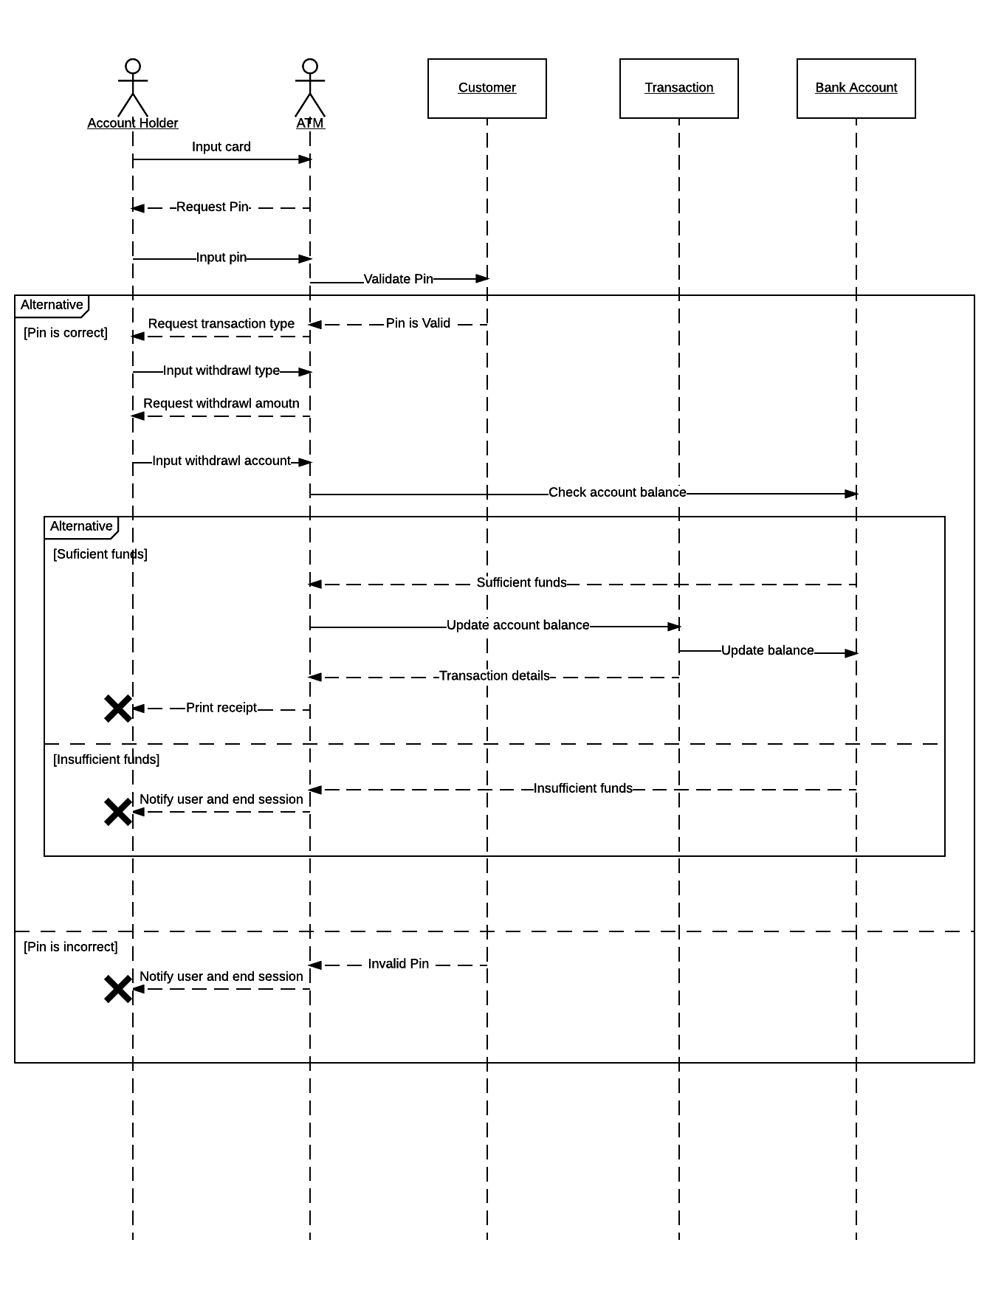

# Class Diagrams

1. Draw a class diagram showing a Car class and it’s relation to a Wheel class. Your drawing should convey the fact that a Car has 4 Wheels.

Drawing:

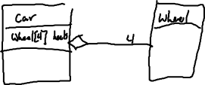

Identify: What relationship is this?



1. Draw a class diagram showing a Company class composed of one or more Department classes. Departments can not exist if the Company doesn’t exist.

Drawing:

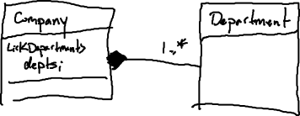

Identify: What relationship is this?



1. Draw: A BankAccount class and two derived Classes CheckingAccount and SavingsAccount.

BankAccount methods: deposit(amount), withdrawl(amount), attributes: owner, balance

CheckingAccount methods: processCheck(), attributes: insufficientFundsFee

SavingsAccount methods:depositMonthlyInterest(), attribute: annualInterestRate

Drawing:

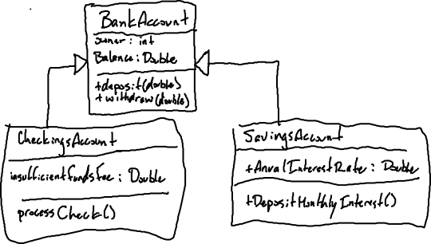

Identify: What relationship is this?



1. Draw: An Order class is created by the ShoppingCart Class, updated by the Warehouse class and the Shipping class.

Drawing:

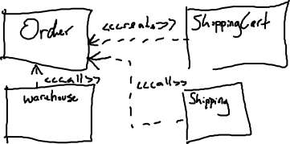

Identify: What relationship is this? Hint: see



# Part C - Assessment

1. What did you learn in completing this lab?



1. What did you have difficulty with?
2. What did you do well?

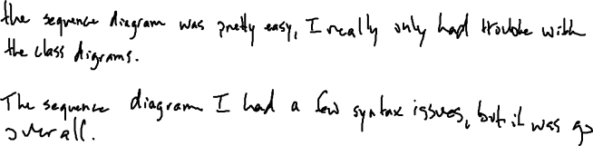

1. How many hours did you spend in completing this lab?



1. What took you the most time?



To Submit



Paste your diagrams into this file and submit to Moodle.